University of the People

MATH 1211 Calculus 1

Unit 6 Written Assignment

Anonymous Student

1. An airplane is flying towards a radar station at a constant height of 6 km above the ground. If the distance s between the airplane and the radar station is decreasing at a rate of 400 km per hour when s=10 km., what is the horizontal speed of the plane? Make sure your answer includes units.

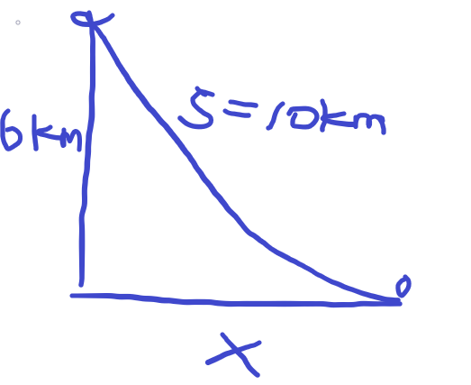

We know the relationship between the distance and the height and the horizontal distance is the Pythagorean formula.

x(t)2+6km2=s(t)2

when s = 10 km , x(t)= 100-36 = 64 = 8km

By taking the derivative of two sides.

$$\frac{dx}{dt}x=\frac{ds}{dt}s$$

$$\frac{dx}{dt}8km=\frac{400km}{hour}*10km$$

$$\frac{dx}{dt}=\frac{500km}{hour}$$

The horizontal speed of the plane is 500km/hour

2. A boat is being pulled into a dock by a rope attached to it and passing through a pulley on the deck, positioned 6 meters higher than the boat.  If the rope is being pulled in at a rate of 3 meters/sec, how fast is the boat approaching the dock when it is 8 meters from the dock? Make sure your answer includes units.

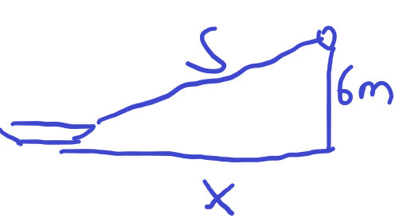

We know the relationship between the rope and the dock and the boat is the Pythagorean formula.

x(t)2+6m2=s(t)2

when x = 8m , s(t)= square root (36+64) = 10m ,

By taking the derivative of two sides.

$$\frac{dx}{dt}x=\frac{ds}{dt}s$$

$$\frac{dx}{dt}8m=\frac{3m}{sec}*10m$$

$$\frac{dx}{dt}=\frac{3.75m}{sec}$$

The horizontal speed of the boat is 3.75m/sec approaching the dock when the distance is 8m.

3. A girl is flying a kite on a string. The kite is 120 ft. above the ground and the wind is blowing the kite horizontally away from her at 6 ft/sec. At what rate must she let out the string when 130 ft of string has been released? Make sure your answer includes units.  
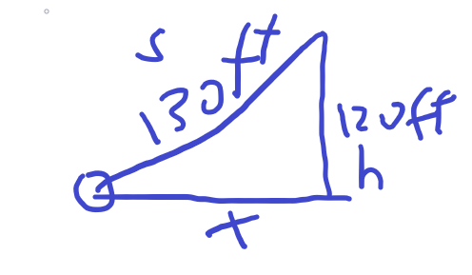

We know the relationship between the string and the kite and the girl is the Pythagorean formula.

x(t)2+120ft2=s(t)2

when s = 130ft , x(t)= square root (1302-1202) = 50m,

By taking the derivative of two sides.

4. Find the Linearization of **[ f(x) =sin x ](https://my.uopeople.edu/filter/tex/displaytex.php?texexp=%20f%28x%29%20%3Dsin%20x%20)** at **[ a= \frac{ \pi}{2} ](https://my.uopeople.edu/filter/tex/displaytex.php?texexp=%20a%3D%20%5Cfrac%7B%20%5Cpi%7D%7B2%7D%20)**. Provide your answer as **[
    L(x) = ](https://my.uopeople.edu/filter/tex/displaytex.php?texexp=%0D%0A%20%20%20%20L%28x%29%20%3D%20)**?  
L(x) =f(a) + f’(a)(x-a)

We know a= π/2

F(a) = Sin(a)=1

F’(x) = cos(a)=0

Then L(x) = 1+0*(x-a) = 1

Thus the linear approximation of f(x) is L(x) = 1

5. Use Linear Approximation to estimate **[ e^{(-0.01)} ](https://my.uopeople.edu/filter/tex/displaytex.php?texexp=%20e%5E%7B%28-0.01%29%7D%20)**. Provide your answer in 2 decimal places.  **Do not** use a calculator. Show work for credit.

Let f(x)=ex , we will find linearization function at x= 0

L(x)=f(a)+f’(a)(x-a) = ex+ea(x-a)

L(0)=f(0)+f’(0)(x-0) = 1+x

F(-0.01)≈L(-0.01) = 1-0.01=0.99

6. Calculate the locations of maximums and minimums of the following functions: Show work in details.

* [ f(x) = x^3 - 3x + 2 ](https://my.uopeople.edu/filter/tex/displaytex.php?texexp=%20f%28x%29%20%3D%20x%5E3%20-%203x%20%2B%202%20)
* [ f(x) = x^4 - 8x^2 + 3 ](https://my.uopeople.edu/filter/tex/displaytex.php?texexp=%20f%28x%29%20%3D%20x%5E4%20-%208x%5E2%20%2B%203%20)

a) f(x) is overall interval (−∞,∞) , the f(x) can be factor into f(x) =(x-1)(x-2)

f(x) is differentiable over this interval when f’(c)= 0 , c is the local extreme.

F’(x)= 3x2-3 = 0 ,then x=+1 its the extreme.

F(1)=1-3+2 =0. F(-1) =-1 +3+2 = 4

We know for (x-1)(x-2) ,function will have intercept with x-axis.

So the function have

local maximum f(-1) =4 and

local minimium f(1)=0.

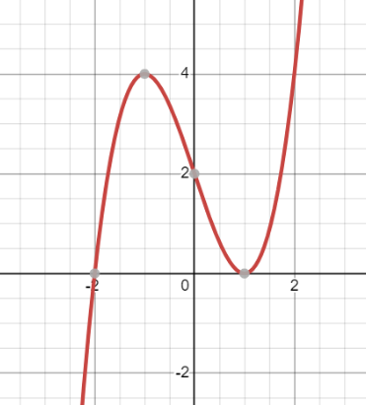

The absolution maximum and minimium is interval (−∞,∞);

b) [ f(x) = x^4 - 8x^2 + 3 ](https://my.uopeople.edu/filter/tex/displaytex.php?texexp=%20f%28x%29%20%3D%20x%5E4%20-%208x%5E2%20%2B%203%20)

f’(x)=4x3-16x

for f’x = 0 , 4x(x2-4)=0, thus the solution of x is

x= 0 or

x=+2

f(0)=3

f(2)=16-32+3=-13

f(-2)= 16-32+3=-13

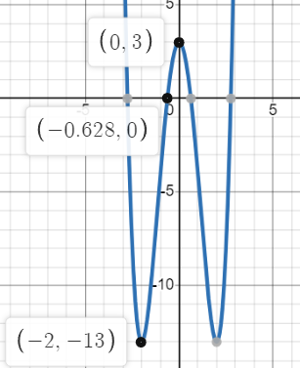

Thus the absolution minimium is f(-2) and f(2)=-13

Local maximium f(0)=3 , absolution maximum is ∞

7. Find the exact x-value where the function [ f(x)=x+ln ](https://my.uopeople.edu/filter/tex/displaytex.php?texexp=%20f%28x%29%3Dx%2Bln%20) ([ x^2-1 ](https://my.uopeople.edu/filter/tex/displaytex.php?texexp=%20x%5E2-1%20)) attains a maximum value. An estimated answer or a calculator answer will not earn any credit.

To find the extreme point

F’(x) = 1 + $\frac{1}{x^{2}-1}2x$

We know that for the derivative to exist x^2!=1

Thus x!=+1

And for

F’(x)= 0

1-x2=2x

X2+2x=1

X2+2x-1=0 thus

X=-1+√2 or -1-√2

Thus the extreme value is when f(-1+√2) and f(-1-√2)

f(-1+√2) = √2-1 + ln(2-2√2)

f(-1-√2) = -√2-1 + ln(2+2√2)

and ln(x^2-1) domain of x^2-1 >0 thus x>1 or x<-1

so only the -1-√2 <-1 is the valid solution and

-1+√2 is not >1 thus its not valid solution.

So the maximum value is at

f(-1-√2) = -√2-1 + ln(2+2√2)

8. Using the Mean Value Theorem and Rolle’s Theorem, show that[ x^3+ x - 1
= 0 ](https://my.uopeople.edu/filter/tex/displaytex.php?texexp=%20x%5E3%2B%20x%20-%201%0D%0A%3D%200%20)  has exactly one real root.

If the f(x) = x3+x-1 is only having a real root thus.

In the domain f’(c) = 0 will only have one solution that

Only one extreme point.

F’(x) = 3x2+1 , thus f’(x) >=1 for all x over the interval. According to mean value,

F(x) is increasing function overall its inverval.

We know that f(-1) = -3< 0 and f(1) = 1+1-1=1, thus the function go throught

x-axis exact once thus, it only have one real root.

9. If [ f(1)=10 ](https://my.uopeople.edu/filter/tex/displaytex.php?texexp=%20f%281%29%3D10%20) and [ f'(x) \geq 2 ](https://my.uopeople.edu/filter/tex/displaytex.php?texexp=%20f%27%28x%29%20%5Cgeq%202%20) for [ 1 \leq x \leq 4 ](https://my.uopeople.edu/filter/tex/displaytex.php?texexp=%201%20%5Cleq%20x%20%5Cleq%204%20), how small can[ f(4) ](https://my.uopeople.edu/filter/tex/displaytex.php?texexp=%20f%284%29%20)  possibly be? 

According to mean value theorem, if f’(x) >0 for all values in its internval, thus f(x) is increasing function. Thus the smallest value is at f(1).

F(1)=10.

We let f’(x) as the smallest value = 2.

Thus

F’(c)= f(b)-f(a)/b-a = 2

F(4)-10/4-1=2

F(4)-10=6

F(4)=16 is the smallest possible value.

10. The graph of a function is given below. Determine the intervals on which the function is concave up and concave down.

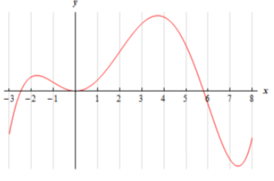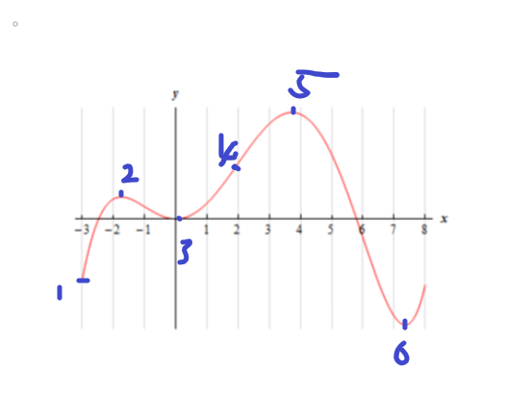

|  |  |  |  |  |
| --- | --- | --- | --- | --- |
| Number | Sign of f’ | Sign of f’’ | Increase or decese | cancavity |
| 1-2 | + | - | Increasing | Concave down |
| 2-3 | - | + | Decresing | Concave up |
| 3-4 | + | + | Increasing | Concave up |
| 4-5 | + | - | Increasing | Concave down |
| 5-6 | - | - | Decresing | Concave down |
| 6+ | + | + | Increasing | Concave up |